UNITED NATIONS  United Nations Mission for the  Referendum in  Western Sahara | 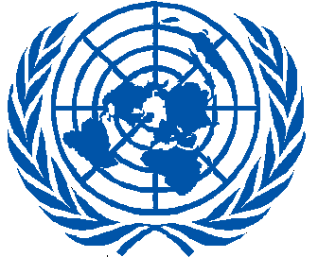  MINURSO | NATIONS UNIES  Mission des Nations Unies pour  l’Organisation d’un Référendum au  Sahara Occidental

Press release

SRSG Kim Bolduc arrives in Laayoune
Laayoune, 6 February, 2015

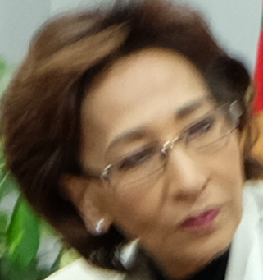

On 6 February, Kim Bolduc, Special Representative of the Secretary-General for Western Sahara (SRSG) and Head of MINURSO, arrived in Laayoune. Prior to her arrival to the Mission area, she visited Rabat where she met with Salaheddine Mezouar, Morocco’s Minister of Foreign Affairs and Cooperation, and Mohamed Hassad, Morocco’s Minister of the Interior. Hamid Barez, Morocco’s Coordinator with MINURSO, participated in both meetings.
“I am honoured to serve the United Nations here in Western Sahara, in implementing MINURSO’s mandate as defined by the United Nations Security Council. I strongly believe that MINURSO is an important instrument of the United Nations in the service of global peace and security. I look forward to working with all relevant interlocutors during my tenure here in MINURSO”, said Bolduc upon her arrival in Laayoune.

