UNITED NATIONS  United Nations Mission for the  Referendum in  Western Sahara | 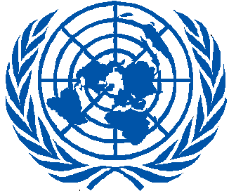  MINURSO | NATIONS UNIES  Mission des Nations Unies pour  l’Organisation d’un Référendum au  Sahara Occidental

Press release

SRSG Kim Bolduc visits Tindouf

Laayoune, 8 February, 2015

On 7 February, Kim Bolduc, Special Representative of the Secretary-General for Western Sahara (SRSG) and Head of MINURSO, visited the Saharawi refugee camps near Tindouf (Algeria). She was welcomed by the POLISARIO Coordinator with MINURSO, M’Hamed Khadad.
The SRSG departed for Smara Refugees Camp, where she had a meeting with the POLISARIO leadership, including Abdelkader Taleb Omar of the National Secretariat, Khatri Adduh, head of the National Assembly, M’Hamed Khadad, Chief of Defence Mohamed Bouhali, Head of Political Orientation Salem Lemsir and Head of the Saharawi Women’s Union Fatma Mehdi.
“I am honoured to serve the United Nations in Western Sahara, am grateful for the welcoming reception by the inhabitants of Smara camp. I look forward to working with all relevant interlocutors during my tenure here in MINURSO”, said Bolduc.

